Group Members: Carl, Keith, John

Carl’s Results:
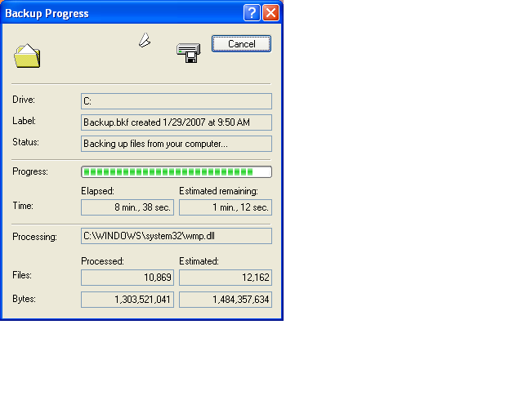
Carl installed Java on his VM and setup environment variables.

Keith’s Results:
I restored Backup.bkf, which contains everything EXCEPT system state. My background changed, and the Java files were there. The environment variables were not set for Java. The passwords also did not change.

John’s Results:
John restored Backup2.bkf, which contains everything including system state. His background changed, and Java was setup correctly. The passwords changed, and the machine was exactly like Carl’s image was.

